**Timers and Interrupts**

**Task 04**



Spring 2022

CSE-307 Microprocessor Based system Design

Submitted by: **Ashfaq Ahmad**

Registration No: **19PWCSE1795**

Class Section: **B**

“On my honor, as student of University of Engineering and Technology, I have neither given nor received unauthorized assistance on this academic work.”

Student Signature: ______________

Submitted to:

**Dr: Bilal Habib**

**May** 23, 2022

**Department of Computer Systems Engineering**

**University of Engineering and Technology, Peshawar**

**Task:**

* Design a system, where the Software in C will generate, a signal of

1. 0.5 KHz with a duty cycle of 25% on P2.0 pin.
2. Whenever a user presses a button at (P3.2), the signal toggles to 1 KHz with a duty cycle of 50%.
3. Again, pressing the same button will generate a signal of 2 KHz with a duty cycle of 75%. A third time button press will result in the generation of case A and so on.

* Draw the schematic diagram showing clearly the button circuit and oscilloscope.
* Draw the timing diagram with cursors clearly showing the time period with appropriate units.
* Assuming oscillator clock of 24MHz is used.
* Use timer interrupt.

## Problem Analysis:

**Case A:** To generate a signal of frequency 0.5 kHz we need a time period of 1/0.5k s So T = 1/f = 1/0.5 = 2ms

T = 1 ms

As Duty Cycle is 25% so

P1.1 →ON (0.5 ms) P1.1→OFF(1.5 ms)

**Case B:** To generate a signal of frequency 1k Hz we need a time period of 1/1k s So T = 1/f = 1/1k = 1ms

T = 1 ms

As Duty Cycle is 50% so

P1.1 →ON (0.5 ms)

P1.1 →OFF (0.5 ms)

**Case C:** To generate a signal of frequency 2 kHz we need a time period of 1/2 s So T = 1/f = 1/2k = 0.5 ms

T = 0.5 ms

As Duty Cycle is 75% so

P1.1 →ON (0.375 ms)

P1.1 →OFF (0.125 ms)

**Source Code:**

#include <reg51.h>

#include <stdio.h>

sbit signal=P2^0;

sbit button=P3^2;

unsigned int count=0;

void delay(unsigned char th0,unsigned char tl0)

{

TMOD=0x01;

TH0=th0;

TL0=tl0;

TR0=1;

while (TF0==0);

TF0=0;

TR0=0;

}

void ISR() interrupt 0

{

count=count+1;

}

void main()

{

IE=0x81; //EA=1 and EX0=1;

IT0=1;

signal=1; //make input pin.

button=1; //initially button not pressed.

while(1)

{

if(count%3==0)

{

signal=1;

delay(0xFC,0x18); //0.5 ms

signal=0;

delay(0xF4,0x48); //1.5 ms

}

else

if(count%3==1)

{

signal=1;

delay(0xFC,0x18); //0.5 ms

signal=0;

delay(0xFC,0x18); //0.5 ms

}

else

if(count%3==2)

{

signal=1;

delay(0xFD,0x12); //0.375 ms

signal=0;

delay(0xFF,0x06); //0.125 ms

}

}

}

**Outputs:**

**Case A:**

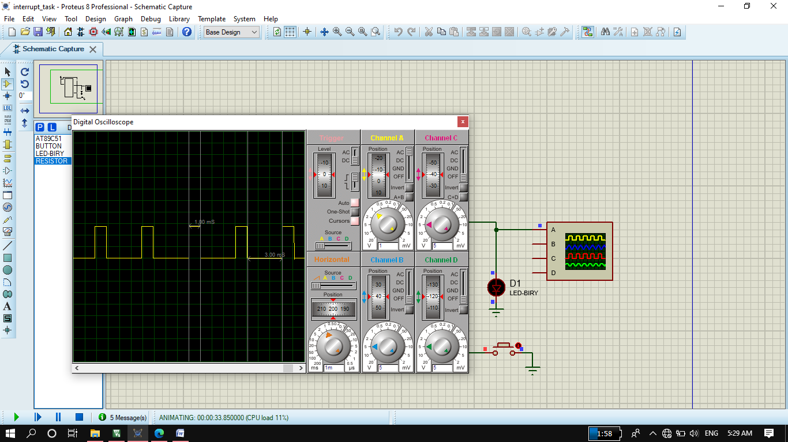

**Case B:**

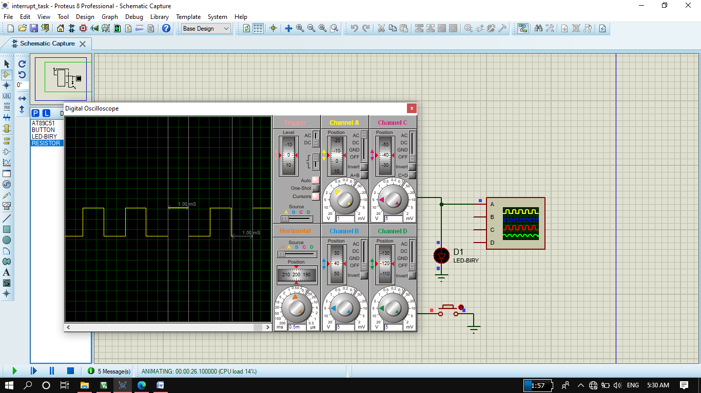

**Case C:**

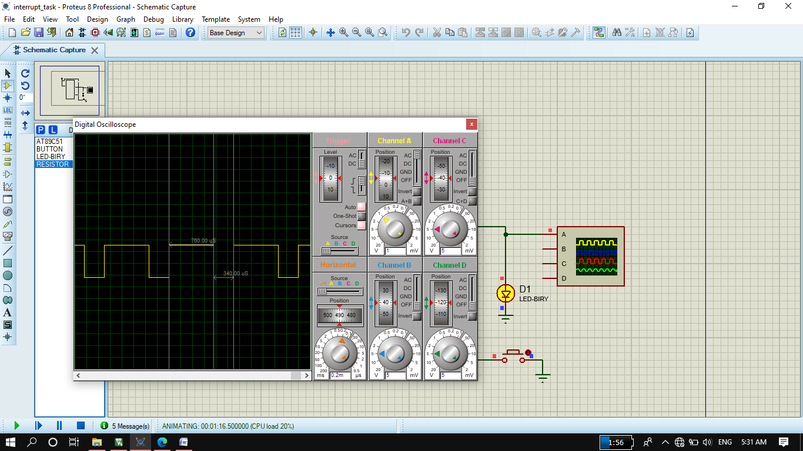

**Circuit:**

